**You will need to create a one-page proposal that includes:**

**● A brief articulation of your chosen topic and rationale**

We plan on making a map for people who are interested in moving to Japan, visiting Japan, or for a business interested in locating a branch in Japan. This map will include information on train stations, universities, population, life expectancy, and cities in each prefecture. A dropdown menu will be included so the user can select one of the 47 prefectures in Japan and then display information about their chosen prefecture, the user will also be able to click on the map to display information about a prefecture. Additional information displayed when choosing a prefecture from the dropdown menu will include, top five universities in a prefecture, average life expectancy, population, train stations. There will also be two bar charts comparing life expectancy by prefecture and population by prefecture.

**● A link to your dataset(s) and a screenshot of the metadata, if it exists.**

World Cities Database (worldcities.csv) <https://simplemaps.com/data/world-cities>

Japan life Expectancy (Japan_life_expectancy.csv) <https://www.kaggle.com/datasets/gianinamariapetrascu/japan-life-expectancy>

Japanese Universities <https://www.kaggle.com/datasets/webdevbadger/japanese-universities>

Japen Prefecture Latitude Longitude (Japan_prefecture_latlng.csv) https://www.kaggle.com/datasets/corochann/japan-prefecture-latitude-longitude

Shinkansen Stations in Japan <https://www.kaggle.com/datasets/japandata509/shinkansen-stations-in-japan>

City and prefecture

Prefecture.csv (<https://github.com/nobuf/list-of-cities-in-japan/blob/master/build/prefectures.csv>)

Cities_in_japan_2023.csv (<https://github.com/nobuf/list-of-cities-in-japan/blob/master/build/cities_in_japan_2023.csv>)

**● Three or four screenshots of relevant, “inspiring” visualizations that show your creative ideas (visualization track only)**

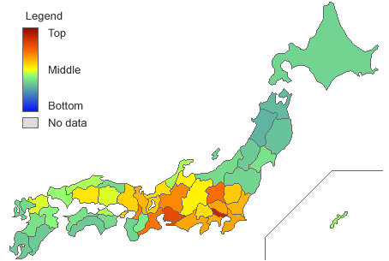

**● A sketch of the final design**

Drop down menu to choose prefecture

Map of Japan

Info displayed when prefecture is chosen

Bar graph of life expectancy by prefecture

Bar graph of population by prefecture

**● A link to the primary GitHub repository where you’ll be housing your work**

<https://github.com/Dizzybelle/Project-3>